AQUARIUS™ Cleaning System Model AQ-5-1728

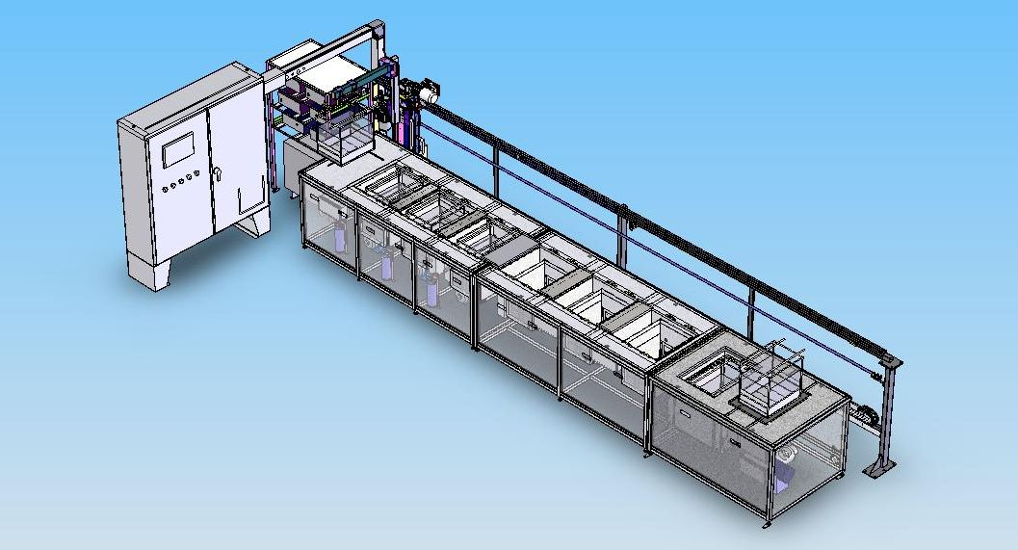
The image above depicts a typical system (in this case showing two additional stages) and may illustrate other features than those offered in the quotation below.

1.0 TECHNICAL SPECIFICATIONS
Model # : AQ-5-1728
No. of Stages : Five (plus load and unload stages)
Tank Dimensions : 17”LR x 28”FB x 15”Ht (Liquid level – 12”)
Basket Dimensions : 13”LR x 24”FB x 5”Ht
Individual Bath Capacity : 25 gallons
Tank Construction : Material -
316L Stainless Steel for all liquid tanks
304 Stainless Steel for dryer
All tanks are fabricated using best manufacturing procedures and incorporate construction details proven appropriate for high intensity ultrasonic applications. All interior surfaces are finished suitably for use in critical cleaning applications.
Console Construction : The console enclosure containing the process tanks consists of a tubular stainless steel framework with stainless steel panels enclosing the front, back and ends of the system. Panels are easily removable to facilitate maintenance when required. The top of the console incorporates a raised edge on all sides to contain spills.
Plumbing : All plumbing including pumps, filter housings and valves is of stainless steel construction. Stainless steel tube or pipe utilizes threaded or compression fittings. Tank fittings are all double welded. Plumbing unions are provided wherever appropriate to allow for easy servicing if necessary.
Electric Heat : Wet tanks - Heaters sized to heat from 65ºF to 150ºF in two hours or less with the tank uncovered.
Dryer – Finned air heaters to heat up to 250ºF.
U/S Power : 1,000 W RMS output in all four liquid tanks.
U/S Frequency : 25 kHz
U/S Transducers : Piezoelectric transducer elements bonded to the radiating surface (bottom of tank).
U/S Generators : Qty 4 total - Neptune™ C Series ultrasonic generators, each with 1,000 Watt output capacity, line synchronized amplitude modulation and high frequency sweep for optimum performance.
Low liquid level protection : Low liquid level sensors in each tank interlocked to the heaters, pumps, and other functions sensitive to liquid level as appropriate.
Fill Management : Unless otherwise noted, the liquid tanks have automated inlet valves connected to a customer supplied water source to fill tanks as required.
Drains : Stainless steel plumbing and manual valves are provided on all tanks and reservoirs not otherwise plumbed to drain.
Ventilation : All tanks will be equipped with lip vents with duct connections to be attached to a customer supplied powered exhaust system.
Material Handling : The CAL-100 is a single-headed cantilevered arm style material handling system. This robotic system features crash protection and other protective features. The system has multi-recipe selection and basket tracking allowing the operator to determine the status of any basket in the system at any time via a touch screen operator interface panel.
Controls : All system controls will be ergonomically mounted on the electrical enclosure located near the load end of the system. Automation includes a PLC and a touch-screen operator interface which controls all machine functions as well as the function of the CAL-100 material handling system.
Power Supply : 480 V, 3Ø, 60 Hz.
A fused disconnect will be provided on the enclosure door.
2.0 CLEANING SEQUENCE: AQ-5-1728 (12” Liquid Level) 25 Gallon Tank Capacity

 |  | Tank 1 | Tank 2 | Tanks 3 & 4 | Tank 5
 |  | Wash Tank | Wash Tank | Two Cascading Rinse Tanks | Recirculating Hot Air Dryer
Process | Single Basket Load Station with Basket Sensor | Ultrasonic Cleaning - Aqueous 150ºF | Ultrasonic Cleaning - Aqueous 150ºF | Ultrasonic Rinsing - DI Water 150ºF | Hot Air Dry 250ºF | Single Basket Unload Station with Basket Sensor
Tank Design |  | 316L Stainless Steel  TIG Welded | 316L Stainless Steel  TIG Welded | 316L Stainless Steel  TIG Welded | 304 Stainless Steel  TIG Welded
Insulation |  | Thermal/Sound | Thermal/Sound | Thermal/Sound | Thermal
Ultrasonics |  | Neptune™ 25 kHz  PLC Controlled – 1000 Watts | Neptune™ 25 kHz  PLC Controlled – 1000 Watts | Neptune™ 25 kHz  PLC Controlled – 1000 Watts (Each) | N/A
Heat |  | Electric Strip Heaters  Digital Temperature Control | Electric Strip Heaters  Digital Temperature Control | Electric Strip Heaters  Digital Temperature Control | Finned Electric Heaters  Digital Temperature Control
Fill |  | Auto-Fill from Customer Supply | Auto-Fill from Customer Supply | Auto-Fill with Flow Meter from Customer Supply | N/A
Weir |  | Single-Sided Overflow Weir with Sparger Return at Liquid Level | Single-Sided Overflow Weir with Sparger Return at Liquid Level | Single-Sided Overflow Weirs - Water Overflows to Previous Tank. First Tank Overflows to Drain | N/A
Filtration |  | 10μm Cartridge Filter with Recirculation Pump and Pressure Gauge | 10μm Cartridge Filter with Recirculation Pump and Pressure Gauge | None | Filtered Make-Up Air
Ventilation |  | Lip Vents On All Liquid Tanks with Manifold to Connect to Customer’s Powered Extraction System |  |  | Duct Connection with Adjustable Damper to Exhaust Humid Air
Drain |  | Each Tank is Equipped with a Manual Drain Valve. All Drains Empty into a Common Receiver Tank from which the Collected Effluent is Automatically Pumped to a Remote Drain Location |  |  | N/A
Special Features |  | Optional Conductivity Meter |  | Optional Resistivity Meter | N/A
Lid |  | Lift-Off Lid | Lift-Off Lid | Lift-Off Lid | Automated Lid

3.0 Additional Descriptions of Features
3.1 System Automation (Automatic Material Handling System CAL-100)
This is an automatic, programmable, cantilevered arm handing system for transferring the parts baskets (Max. load capacity – 100 pounds) from a load station to the various process tanks and subsequently to the unload station for removal by the operator. In this instance, the load station is on the left side of the system and the unload is on the right as facing the front.
An Allen-Bradley CompactLogix PLC will be used for motion control of the material handling system. Operator interface will be provided by a 10” Allen-Bradley color touch screen panel. Manual controls are provided for alternate manual operation of the material handling system. Process times and other parameters including ultrasonic operation can be preset by the operator using a password protected setup screen.
The Material Handling System includes the following:
- Location of all system controls to a free standing NEMA enclosure mounted near the load end of the system. This enclosure contains the PLC required to control the material handling system and the necessary integration to control various system features as described below.
- Load and Unload stations at opposite ends of the system with a basket sensor on each.
- Multiple programmable recipes (number depends on program complexity). Each recipe will store cycle times for each process tank and allow tank skipping ability (process flow must remain left to right – no sequence shifting).
- Automated dryer lid.
- Basket locators for each tank.
- Weekly timer to control heaters when the system is not manned.
- Safety pull cord the entire length of the system.
- Automation interface for the system which enables programmed control of the following system functions:
- Ultrasonics ON/OFF
- Filter units ON/OFF
- Dryer ON/OFF
- Dryer Lid OPEN/CLOSE
- Other Process Functions as Required
3.2 Ultrasonics
Tanks with ultrasonics are fitted with state of the art piezoelectric transducers designed and manufactured by Blackstone-NEY Ultrasonics. Unless otherwise noted, transducers are immersible style mounted in the tank bottom. Transducers are permanently attached using bonding processes unique to Blackstone-NEY Ultrasonics and are guaranteed for the lifetime of the radiating surface to which they are attached.
Ultrasonic transducers are powered by Neptune™ Series C ultrasonic generators designed and built by Blackstone-NEY Ultrasonics. These generators operate at a frequency of 40 kHz and feature both amplitude and frequency modulation to provide superior cleaning performance under a wide range of operating conditions. Generators will be mounted inside the main electrical enclosure or on a shelving unit located near the main electrical enclosure.
Operation of ultrasonic generators is controlled automatically by the system PLC.
3.3 Heat with Digital Temperature Control
Liquid Tanks –
Liquid tanks with heat are fitted with electric strip heaters mounted on the external tank side wall(s). These heaters are controlled by a digital temperature controller utilizing a thermocouple type sensor which is also attached to the side wall of the tank. All heated tanks are provided with thermal insulation.
Dryer –
The hot air dryer is heated by finned electric heaters mounted in the air plenum. A high volume blower (rated at 1000 CFM) draws air from the dryer chamber, pushes it through the finned electric heaters, and returns it to the chamber. The bottom of the dryer has a diffuser that evenly disperses the heated air. The heat is controlled by a digital temperature controller utilizing a thermocouple type sensor which is in the airflow path. All dryers are provided with thermal insulation.
3.4 Overflow Weir –
Liquid tanks fitted with an overflow weir have an overflow lip positioned at one side of the tank with an open reservoir below. Liquid from the reservoir is plumbed to the preceding tank as makeup, to drain, or to a collection fitting for re-use.
Overflow Weir and Sparger -
Liquid tanks fitted with an overflow weir and sparger have an overflow lip positioned at one side of the tank with an open reservoir below. Liquid from the reservoir is pumped back to the tank through a flow control valve and a series of holes at liquid level constituting a sparger located on the side of the tank opposite the overflow weir. The flow of liquid from the sparger across the surface of the tank to the overflow serves to remove any floating contamination from the surface of the tank. Removed floating residue collects in the reservoir for periodic manual removal by skimming or by draining through a pipe fitting and valve located in the reservoir.
3.5 Level Protection
Tanks with ultrasonics, heat, and/or pumps are fitted with suitable level sensor(s) to prevent operation of these features when the liquid level in the tank falls below a safe operating level. These sensors are selected to perform reliably when the tank is used with the originally specified process liquid.
3.6 Liquid Fill and Drain
Fill
AutoFill – Tanks with the AutoFill feature have level sensors and are fitted with solenoid valves on the inlets to automatically replenish the liquid level using customer supplied water as required or as described in this proposal.
Controlled Flow – Tanks requiring controlled flow (usually rinse tanks) are fitted with manually operated flow control valves which incorporate a calibrated flow meter to allow setting them to a precise flow rate.
Drain
Manual – Unless otherwise noted, all tanks are provided with manually operated drain valves. Drain valves are located for easy access and are labeled for identification. All plumbing lines will be assembled to minimize effluent left in pipes during the gravity draining cycle.
Overflow to Drain – Overflowing rinse tanks are provided with an overflow weir connected directly to drain to allow a constant flow of fresh rinse water through the tank. Tanks fitted with an overflow drain are also fitted with a drain valve as described above to allow for complete draining of the tank as required.
Pump to Drain – All tank drains flow to a common collection reservoir. Under the control of level sensors, the contents of the collection reservoir are pumped to a remote drain location by a suitable pump capable of pushing up to 10 gallons per minute to a 30 foot water head.
3.7 Re-circulation with Filtration
Liquid tanks fitted with re-circulated filtration systems incorporate an outlet fitting located in the bottom of the tank which is connected to the inlet of a dedicated pump. From the pump, the liquid flows through a canister type filter and is returned to the main volume of the tank through a fitting. An in-line valve provides flow control and the ability to isolate the filter to facilitate changing the filter media as required. The filter housing and filter media are selected based on the amount and nature of contaminant anticipated.
3.8 Lift-Off Lids
Lift-off lids are included for all liquid tanks. These lids are intended to prevent tank contamination and contain heat and vapors during periods when the system is not in use.
3.9 Dryer Lid
The dryer is equipped with an automated lid that opens to expose the tank as needed. This lid is required to assure containment and recirculation of heated air.

3.10 System Modem
A modem is provided which, when connected to an analog telephone line can be used to monitor and revise the PLC program from a remote location. This feature allows Blackstone-NEY Ultrasonics’ engineers to troubleshoot and update programming within the PLC without the expense and possible delay of a service call.
3.11 Documentation
Blackstone-NEY Ultrasonics documentation package includes the following documents provided as hard copies and/or Adobe Acrobat (.pdf) files:
- Overall System Drawing showing basic system layout and location of major components.
- Identification and description of user serviceable parts including filters, fuses, sensors, pump seals, wear bearings, indicators and other parts as deemed necessary for normal maintenance of the machine.
- Electrical Schematic showing wiring detail, identifying wire numbers, and component identification of electrical components.
- Plumbing Schematic.
- Pneumatic Schematic (where applicable).
- A CD copy of the PLC program (if present).
- A full instruction manual (in English) including detailed instructions describing how to operate the system under normal use conditions.

4.0 System Options
4.1 Conductivity Meter (for one wash tank)
A probe mounted in the side wall of the tank will monitor the conductivity of the solution and display the value on the included meter. The meter will be mounted on the front or side of the electrical enclosure. Please specify the tank number(s) at time of order.
4.2 Resistivity Meter (with Rinse to Resistivity) for Tank 4
This feature uses a probe mounted in the side wall of the tank to monitor the quality of the DI rinse water. The value will be displayed on a meter mounted in the control panel area. The resistivity reading will be linked to a stainless steel solenoid water inlet valve and allow fresh DI water to enter the rinse tanks until a desired resistivity is reached. The inlet water valve will then be closed to conserve water.

