Versa Genius 50 IV HDV TD35

Automatic ultrasonic cleaning line

PROPIETARY NOTICE

This proposal includes data that shall not be disclosed to outside parties and shall not be duplicate, used or disclosed – in whole or in part – for any purpose other than to evaluate this proposal. The data subject to this restriction are contained in the entire proposal.

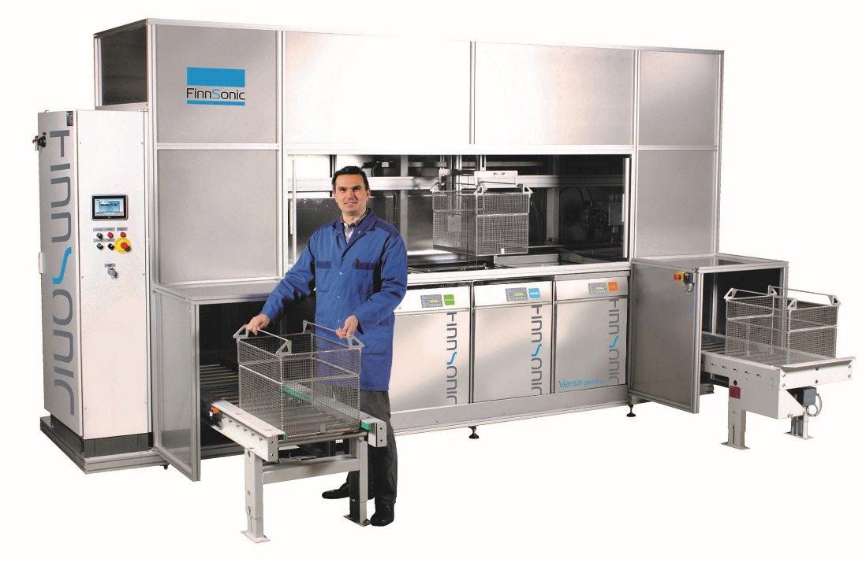

Example photo of automatic Versa Genius cleaning line with full encapsulation (for illustration purposes only, not 100% identical with the quoted product)

## Process stages and functional units

Process direction from left to right

Stage 1

* ultrasonic cleaning, 1200 W, 30 kHz
* basket dunk for vertical agitation
* storage tank, located inside the machine encapsulation
* auto stop/go control for storage tank circulation
* Belki 211 oil separator
* surface spray bar
* 20” stainless filter with 50µ cartridge for fine filtration
* auto refill
* auto detergent dosing

Stage 2

* ultrasonic cleaning 1200 W, 30 kHz
* basket dunk for vertical agitation
* Closed loop filtration with 20” stainless filter with 50µ cartridge for fine filtration
* auto stop/go control for closed loop circulation
* auto refill
* auto detergent dosing

Stage 3

* jet spray under immersion
* Closed loop filtration with 20” stainless filter with 50µ cartridge for fine filtration
* autopurge

Stage 4

* rinse with deionized water
* closed loop deionized water filtration with resin and active carbon filters and 20” stainless filter with 50µ cartridge for fine filtration
* conductivity measurement, measuring range 1micS-1mS

Stage 5

* hot air dryer
* automatic sliding lid to left

Stage 6

* vacuum dryer

Other items included:

* TD35 automatic basket transporter
* full encapsulation with plexi windows, interlocked rear service doors
* filtermist steam condenser
* motorized loading and unloading conveyors, space for 4 baskets on each conveyor
* cooling station with covering for the unloading conveyor
* Siemens PLC
* light beacon
* wash baskets (10 pcs) for Versa Genius 50, with support for customer’s plastic jigs for blades
* usage meters for water, air and power
* Common water inlet and drain connections for all the stages
* drain pump, 8m vertical delivery
* calibration certificates for temperature sensors and pressure meters
* seaworthy packing

## Technical data and utility requirements

|  |  |
| --- | --- |
| **Basket internal dimensions** | 220 x 415 x195(h) mm |
| **Max load kg** | 10 kg |
| **Liquid volume/tank** | 45 l |
| **Ultrasonic power/tank** | 600 W, transducers on tank base |
| **Heating power** | 2 kW / tank, 4 kW / hot air dryer |
| **Process direction** | from left to right as a standard |
| **Voltage (VAC)** | 480 V three phase, 60 Hz |
| **Cable marking** | Level 2, according to FinnSonic technical specification TS15 |
| **Ventilation connection** | Ø150 mm |
| **Compressed air** | 5-7 bar, dry and filtered |
| **Space requirement for the line and servicing** | Ca. 6017 x 3690 x 2980(h) mm, pumps located under the conveyors |
| **Noise level** | 75 ± 3 dBA |
| **Takt time** | Total throughput of baskets depends on required cleaning and drying times. Due to several process variables, no exact capacity figure can be confirmed without further testing. |

Technical data that is not defined in this quotation follow the guidelines of FinnSonic general technical specification TS15.

**Disclaimer of Liability!** Although believed to be true and realistic, cleanliness results, proposed process and capacity estimates contained in this quotation shall be understood as a recommendation and serve as a guideline only. The user shall be fully liable for the process selected. No warranty, guarantee or liability claims whatsoever may be lodged against FinnSonic Oy.

**Excluded items:**

Following items are not included in this quotation, some of them can be offered separately:

1. Demolition/removal of the existing equipment/structure, building work
2. Construction engineering
3. Haulage
4. Installation
5. Lifting equipment needed in installation
6. Makeup air, lighting, heating or cooling of the building, fire extinguishing, etc
7. Water filling and drain lines outside the cleaning line
8. Chemical storage
9. Waste chemical storage
10. Filling/drain pumps
11. Pipes/cables outside the quoted equipment

# Standards, Norms

The machines are CE marked and conform to following European Council Directives, standards and changes related to them:

* EC Machine directive 2006/42/EC
* Electromagnetic Compatibility Directive (EMC) 2014/30/EU
* Low Voltage Directive 2014/35/EU
* Electric equipment, wiring EN 60204 Part 1

# Documentation

According to FinnSonic General Technical Specification TS15

* Each machine is supplied with 1 hard copy of user instructions for the end customer. All documents are made available as 1 soft copy (pdf) for the distributor.
* User instructions are delivered in English. Translation of the user documents to other language is done by the Distributor.
* Installation Instructions in customers local language
* Safety Instructions in customers local language
* User´s Manual in customers local language
* Maintenance Instructions in customers local language
* Mechanical Drawings and Parts Lists in English
* Circuitry Drawings and Parts Lists in English

# FinnSonic Genius ultrasonic technology

* Automatic adaptation of generator parameters – constant maximum power
* Measurement of the load
* Frequency regulation (/30 sec)
* Power regulation (cont)

🡪 Operating in optimal point puts the power into cleaning and minimizes energy losses.

Fully digital technology – extremely controllable and energy efficient

Advanced diagnostics – performance monitoring and service capabilities

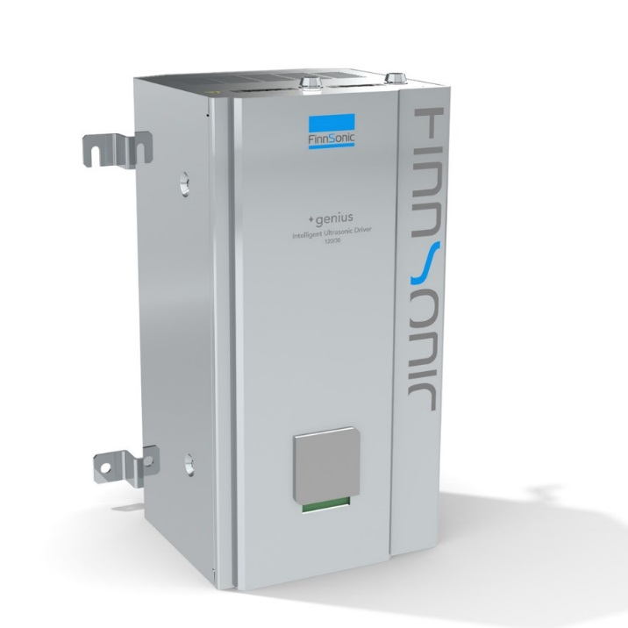

## Quality



FinnSonic has certified quality system ISO9001 for quality and ISO14001 for the environment. High-quality FinnSonic original parts are used when servicing the equipment.